Task 4.1

This task shows the full pipeline for training and deploying a Multiclass Decision Forest on the Iris dataset using Microsoft Azure Machine Learning Studio. Each pipeline step below includes a description of what it does, and the assumption made during implementation.

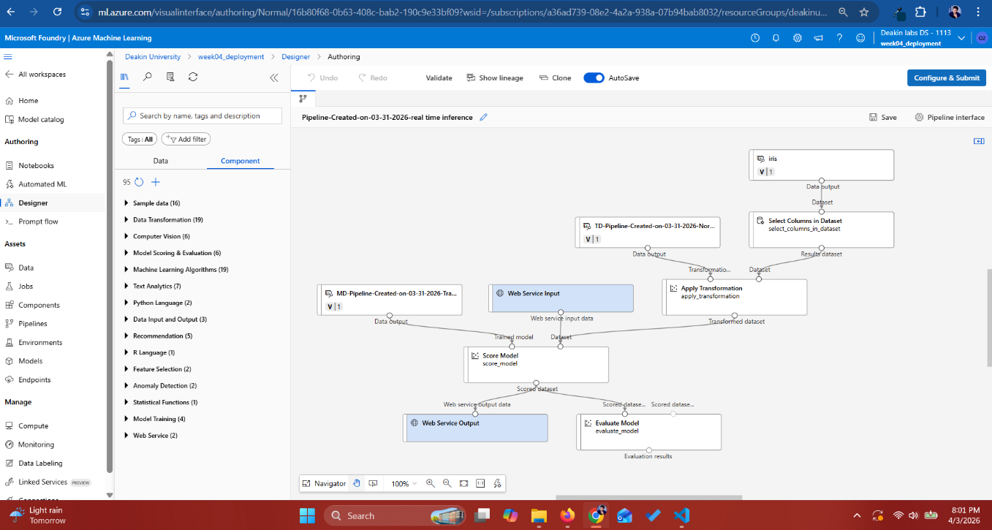

Data Import

The Iris CSV dataset was uploaded to the Azure ML workspace. The data asset schema was auto detected by Azure ML, mapping column types to Integer (Id), Decimal (features), and String (Species). This registered asset is then connected as the input source for the pipeline.
Assumption:
I assumed that the dataset was clean with no missing values, and that the auto-detected schema correctly represented all column types. No manual type overrides were applied at this stage
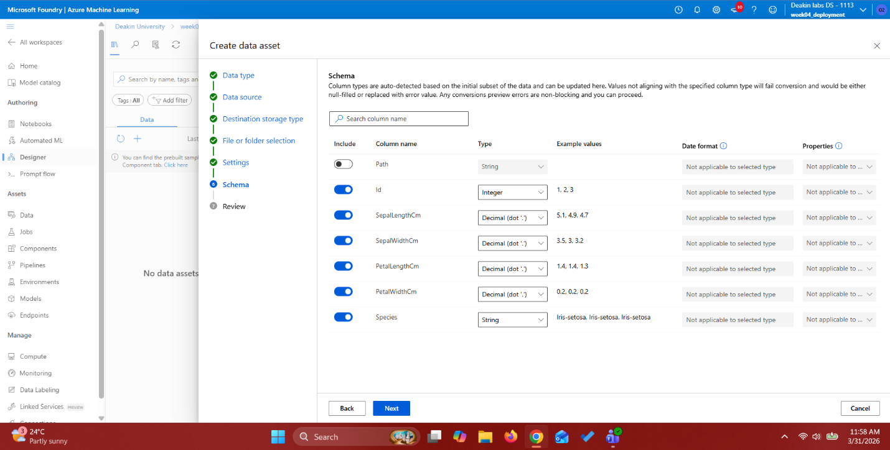

Data Preprocessing
- Select Column in Dataset
The Select Columns in Dataset module was configured to explicitly exclude the Id column. The Id column is a sequential row identifier with no predictive value, and including it would learn spurious correlations tied to row order rather than biological features.

- Normalize data – Z core Normalization
The Normalize Data module was applied to all four numerical feature columns using the Z-score transformation method. Z-score normalization centers each feature around 0 and scales by standard deviation, which prevents features with larger magnitudes from dominating the distance calculations in tree-based splitting.

Test and Split data
The Split Data module was configured with a 0.7 fraction for the training set (70%) and the remaining 30% for testing. Stratified splitting was enabled with Species as the stratification key, ensuring each class appears in proportional representation in both sets. A fixed random seed of 42 was used to guarantee reproducibility across pipeline re-runs.

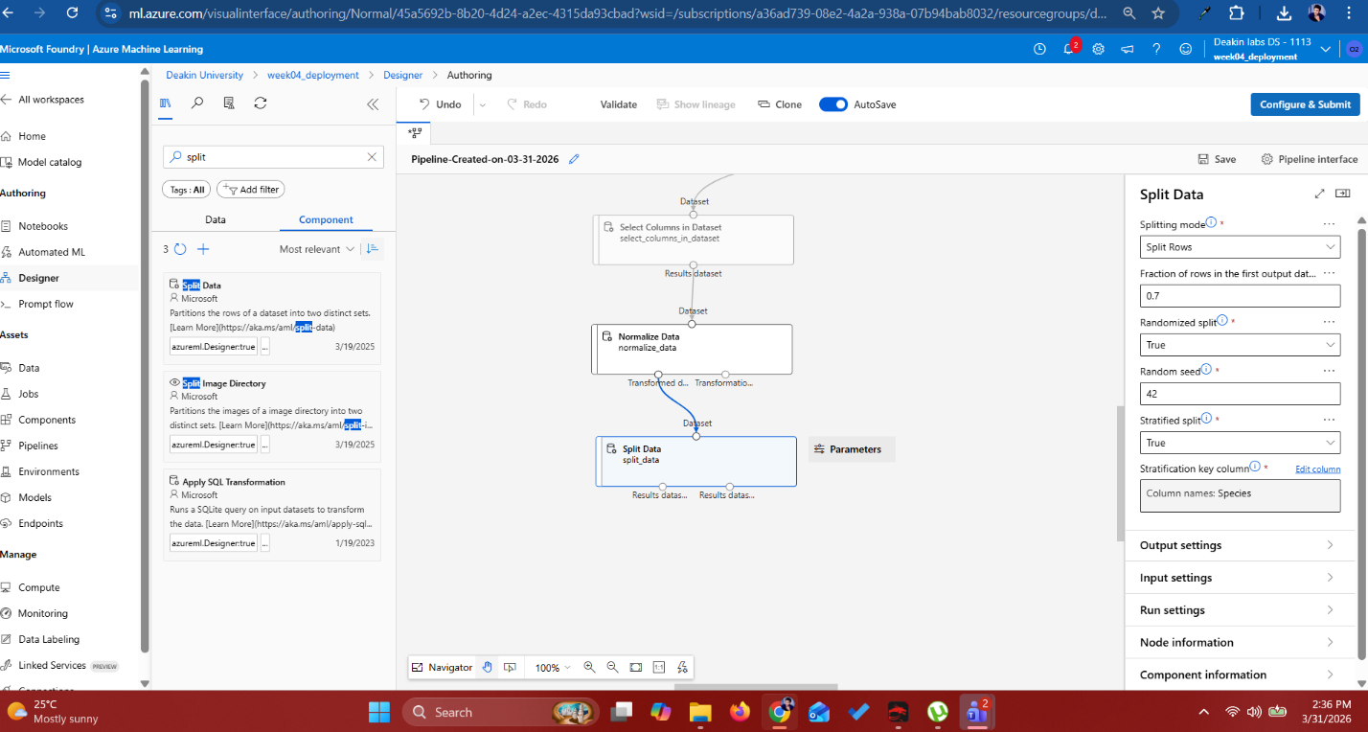

Training Model
A Multiclass Decision Forest algorithm was connected to the Train Model module with Species selected as the label column. The Evaluate Model module was connected to the scored output to assess classification performance. The pipeline ran successfully to completion, as confirmed by the green status indicators on all modules in the Azure ML Jobs view.

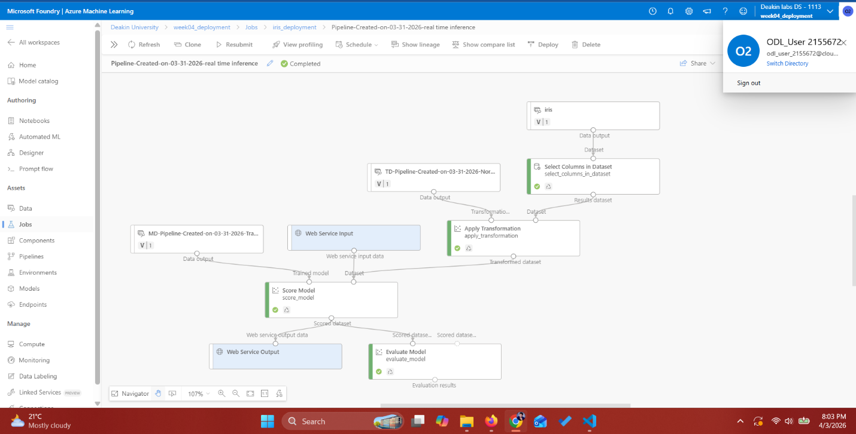

Web Service Input Assumption
It is assumed that all data submitted at inference time will already be pre-processed and clean. Specifically, the Id column will be absent, and all numeric features will have been Z-score normalised by the caller prior to submission.

Python script validation
A Python script was written to validate model availability by sending a REST POST request to the deployed AKS endpoint. The script structure is as follows:

